East Priest Lake Fire Protection District
48 E Lake Trout Lane
Coolin, ID 83821

NOTICE OF
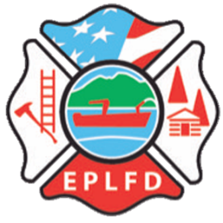
MEETING DATE CHANGE

East Priest Lake Fire Protection District
Board of Commissioners

Commissioner meetings will now be every other month.
The next meeting will be held on
June 16, 2022
6:30 P.M.
at
48 E Lake Trout Lane
Coolin, ID 83821

